Minutes of Ceredigion Snooker League Annual General Meeting held at Aberaeron Hall on Thursday 7’th September 2023.
Present: Adrian Williams (Secretary), Andrew James (Chairman), Dilwyn Smith (Vice Chairman & Fixture Secretary), Dai Morgan (Treasurer), Marc Rees (Felindre), Gerwyn Lloyd (Llanarth), Hywel Davies (Llanon), Andy Green (Rhydlewis), Stafford Morgan (Rhydlewis), Rhodri Morgan (Aberaeron), Eifion Harries (Aberaeron), Jon James (Aberaeron), Mike Newcombe (Rhydlewis), John Owen (Llandysul), Rhydian Owen (Llandysul), Gwynant Ellis (Penparcau), Euros Davies (Llanarth).
- Apologies: Daryl Walters (Aberaeron), Gethin Davies (Rhydlewis), Brian Smith (Llandysul), Emyr Thomas (Beulah) and Stuart Brice (New Quay).
- Minutes of last AGM: The minutes were confirmed to be correct by Rhodri Morgan and seconded by Dai Morgan.
- Matters Arising:
The Secretary stated that he has spoken with Tony Cannon regarding the Team 4 Wales competition and that the intention is to lay on the tournament this coming year. Team names will be needed by October. After a brief discussion it was decided to enter 2 teams this year (North & South Ceredigion).
- Appointment of Officials:
All league officials were reappointed into their posts on block.
Proposed by Stafford Morgan and Seconded by Andy Green.
Appointed Officials 2023/24:
Chairman: Andrew James
Vice Chairman: Dilwyn Smith
Secretary: Adrian Williams
Treasurer: Dai Morgan
Fixture Secretary Dilwyn Smith
President Marc Rees
- League Formation: Tables as at the end of last year
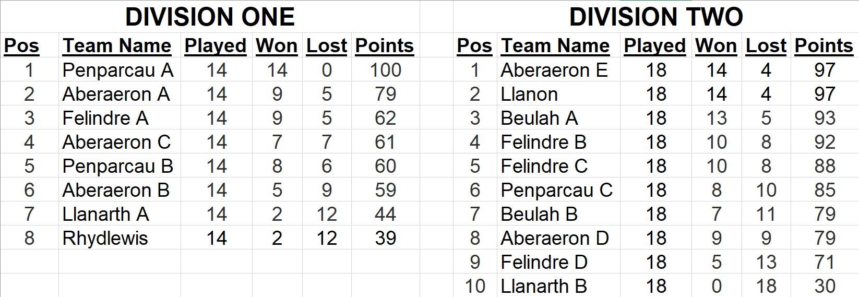
Three new teams have requested to enter the league – Rhydlewis B, Aberaeron D and New Quay.
Four teams have withdrawn from the league – Aberaeron E, Penparcau C, Beulah B and Llanarth B.
The Felindre B team have transferred as Llandysul A and the original Aberaeron D team have transferred as Llandysul B
Felindre C have renamed to Felindre B and Felindre D have renamed to Felindre C.
After some deliberation it was decided to promote the top available team Llanon from Division 2 and do no relegations from Division 1. This would give a split of 9 teams in Division 1 and 8 teams in Division2.
It was agreed that Aberaeron A, Aberaeron B, Penparcau A and Felindre C will play all their games on Wednesdays. Where problems arise with fixture dates then the captains are expected to resolve the issues amongst themselves.
The league formation was proposed by Dai Morgan and seconded by Marc Rees.
It was agreed to start the league on Thursday 5’th October 2023.
The first half of the season will run from 5’th October to 7’th Dec and the second half from 11th Jan to 28’th March.
- Treasurers Report: The Treasurer read out the statement of accounts
He stated that all teams were up to date with their payments and that the accounts were in a healthy state.
The Treasurer’s report was approved and agreed as correct by the committee.
Proposed by Jon James and seconded by Euros Davies.
- Fees:
a) League Fees: It was decided not to change the league fees for the 2023/24 season from £30 per team due to a healthy accounting year. This was proposed by Adrian Williams and Seconded by Dai Morgan.
b) Secretaries Fees: It was agreed not to change the fees from £200 for the 2023/24 season.
Proposed by Rhodri Morgan and Seconded by Andrew James.
c) Web Developers Fees: It was agreed not to change the fees from £50 for the 2023/24 season.
Proposed by Adrian Williams and Seconded by Andrew James.
- Sponsorship and Raffle:
The Secretary stated that our current main sponsor ‘Nisa Ffosyffin’ will be continuing as our main sponsor for the last time. He stated that we are also still looking for a few other sponsors to cover some competition prize money. Stafford Morgan agreed to sponsor one of the tournaments.
It was agreed to do a raffle this coming season. Clubs will therefore be requested to provide raffle prizes for this year’s raffle. Once sufficient prizes have been received then the tickets will get printed to give plenty of time to sell prior to the Presentation evening draw.
- Presentation Evening:
It was agreed to approach the White Swan, Llanon for prices and availability. It was agreed to hold the 2023/24 Presentation at the end of the season around April 2024.

- Proposals:
a) Playing the 3-miss rule in all Division 1 matches (Felindre).
After a lot of debate on the pros and cons of introducing such a big change the proposal was in the end unanimously carried. The Secretary had voiced his concerns on the possibility of players falling out over this and there should be the need for overall authority on decision making where there are no referees available. Mike Newcombe stated that in the Welsh competitions where there no referees present then the player playing the shot has the authority on where the balls are returned to. It was agreed to trial this method. It was also agreed that the Secretary would write out some instructions around how this will get carried out.
b) Playing handicaps in all matches (Aberaeron).
The Secretary stated that in all other leagues that he had researched where the miss rule or 3-miss rule is used there is always player handicaps in play also. The general consensus was that we do not wish to deploy a handicap system into our league matches. This proposal was unanimously not carried.
c) Revising handicap calculations to incorporate high breaks (Penparcau).
After quite a bit of debate it was decided that this would not be fair on a lot of players, particularly where they have not had breaks in some time. It was also deemed unfair and restrictive to many players and would close the handicap advantage for many players and compromise attendance at some of the competitions. This proposal was unanimously not carried.
- Any Other Matters:
a) The Secretary mentioned the work being carried out on a replacement website to the current 13-year-old one in use now. It was agreed to push forward with this to a maximum value of £500.
b) Marc Rees mentioned that Barry Brown should get a mention on the website for representing Wales in the Super Senior competition. The Secretary agreed that he will get the website updated.
c) Andy Green enquired about having a new webpage for our 147 breakers after the recent one achieved by Mike Newcombe. The Secretary agreed that he will get the website updated.
d) The Secretary mentioned that Meurig James of Llanon Snooker club who was a regular player over many years in our league had recently passed away. It was also mentioned that George Muir who was a long-standing secretary of Aberaeron Snooker club had also recently passed away. A minute’s silence was carried out for both of them.
- Date of Next AGM Meeting: It was agreed to hold the next AGM on Thursday 5’th September 2024 at Aberaeron Memorial Hall.

